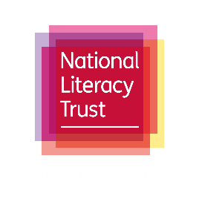

Shakespeare quote video
  - Guidance to contributors

Basic details

Purpose
To encourage more people to get involved with Dr Kate Rumbold’s Shakespeare programme – which uses quotes from Shakespeare as springboards to get people telling personal stories.

Deadline
Wednesday April 19th, 2023
Send videos to kyle.turakhia@literacytrust.org.uk

Content
The video should explain:
- Your name and where you’re based
- What you do now – or a bit about yourself
- When and where you completed Kate’s Shakespeare workshops
- What you felt about the workshops – what did you like about them?
- The Shakespeare quote to which you feel a personal connection
  - Be sure to read the quote in full, slowly
  - If you can, also read out which play the quote is from (e.g. Hamlet).
- Why you feel a connection to that quote – for example:
  - Does it remind you of an experience or time in your life? (If so, tell the story)
  - Does it inspire you? If so, why?
  - Do you think it is good or bad advice? If so, why?
- A call out to new participants – why do you think Shakespeare quotes are powerful today?
If you are not sure which quote to pick, please see the bottom of this document for some options.

Who should be filmed?
Anyone who has participated in Kate’s programme, or feels a connection to a particular Shakespeare quote.

Video length
1-3 minutes

Other assets
If you have any photos that help to tell your story (e.g. you at the place where the Shakespeare workshop was completed, you at a time of your life you are describing in the story) please send these to us with the video and we will edit them in.

Style Guide
- Film yourself using a landscape orientation (see pictures below)! This will make the editing later on much easier.

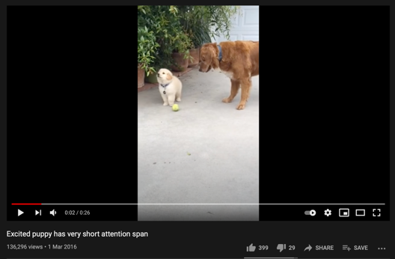
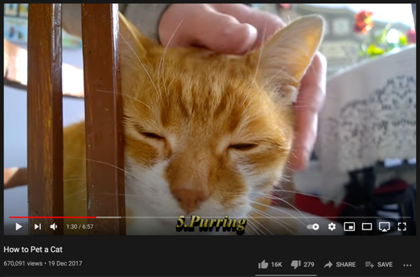
- Choose a quiet room/outside with a neutral background and good lightning (preferably natural daylight) to film
- Please speak more slowly than you would in normal conversation.
- Don’t worry about editing the video; e.g. by adding music. These details need to be added retrospectively to ensure uniformity.

Quote suggestions
If you are not sure which Shakespeare quote to talk about, here are some of the main ones Kate uses in the programme.
- '...we know what we are, but not what we may be' (Hamlet, Act 4, Scene 5)
- 'This above all--to thine own self be true' (Hamlet, Act 1, Scene 3)
- Our destiny: 'not in our stars, but in ourselves' (Julius Caesar, Act 1, Scene 2)
- 'This above all--to thine own self be true' (Hamlet, Act 1, Scene 3)
- 'The course of true love never did run smooth' (A Midsummer Night's Dream, Act 1, Scene 1)
- 'Better three hours too soon than a minute too late' (The Merry Wives of Windsor, Act 2, Scene 2)
- 'Neither a borrower nor a lender be' (Hamlet, Act 1, Scene 3)

