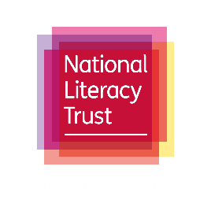
  - Wishes and dreams in When Shadows Fall: Bubble quotes activity

If you could share a wish with someone, who would it be? Do you have a wish for your younger self?
This activity is designed to help pupils read and explore When Shadows Fall by Sita Brahmachari and Natalie Sirett.
We want your class to read Kai, Orla and Zak’s wishes and write or doodle your creative responses.
Introducing the activity
- Hand out or display the wish bubble templates to pupils and ask them in pairs to read Kai, Orla and Zak’s wishes.
- Ask your class to discuss what they think of the characters dreams and whether they have any tips for helping them come true. Who or what do they need to help?
- Read the quotes and discuss pupils’ responses together
- Ask pupils to use the blank lines on the template to respond to Kai, Orla and Zak’s wishes individually. Explain that this is a creative response task and pupils can write or respond in any way they would like to. You might like to offer these suggestions:

- A narrative poem
- A letter of advice to the characters. What advice would you give them to help their wishes come true? What do you think your friends and family wish for? You might like to include your advice to them in your response
- A secret message
- An acrostic poem
- A mantra for Zak, Orla and Kai to live by. Create your own two-sentence message to guide them through difficult times and into happiness or healing
- A rap or short story about a memory on a similar theme

- Don’t forget to share it with us! Send us a photo or video of your pupils creations to hello@getislingtonreading.org.uk or phoebe.eckersley@literacytrust.org.uk
This activity is a great opportunity to promote the wellbeing benefits of reading and writing for your pupils, find a sense of belonging and promote inclusivity in your school during and beyond Refugee Week.

Additional activities
If your pupils enjoyed this activity, you might like to pull out the quotes key themes and invite your pupils to:
- Write a 150-word acrostic or narrative poem ending with the line 'This is what I wish for...' on the subject of:

- Childhood wishes
- Dreams for the future
- My community
- Healing/flying
- Your own ‘Bothy’ – a place where you feel safe and can truly be yourself

- Write a diary entry as your younger self wishing for these things, then write a letter to your younger self, knowing what you know now.
- Do you have wishes for a friend or family member? Write them down and weave them into a poem or rap, starting each line with 'For [name], I wish...'

