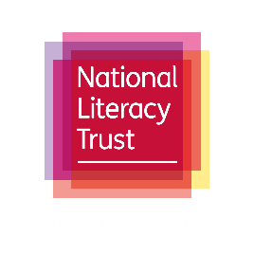

Earth Day 2021

Overview:
The National Literacy Trust, Siemens and Walker Books have worked together to deliver a series of events and learning resources for schools to encourage and promote conversations around climate change and environmental projects to mark Earth Day 2021.
School guidance:
We have designed a whole-school assembly, a classroom-based lesson and a reading lesson designed to be delivered alongside the book Kids Fight Climate Change by Martin Dorey. It is suggested that the reading of the book and/or the whole-school assembly is delivered before the classroom resource.
Ideas for further learning:
Climate corner: your classroom, library or school hall could feature a climate corner hosting posters, bookmarks and challenges on how to help fight climate change. Use the materials and lesson resources provided to create an engaging area in your school where pupils can record and celebrate their actions and promote a reading culture throughout the school.
Writing activity: one of the ideas suggested is to write to a local councillor or MP to encourage more cycle lanes in your local community. This could be amended to promote writing for pleasure and could be a letter to a friend, headteacher or community leader to help tackle climate change. The activity could be scaffolded to suit all key stages and could discuss the issues around climate change, or propose a new feature in school or the local area to help tackle climate change.
Reading activity: continue learning about the environment by using cross-curricular links to promote reading for pleasure throughout your school. Feature texts from geography, science, citizenship or books with a similar theme to continue promoting an understanding of the environment and climate change, and to foster enthusiasm in pupils around reading and climate change challenges.

