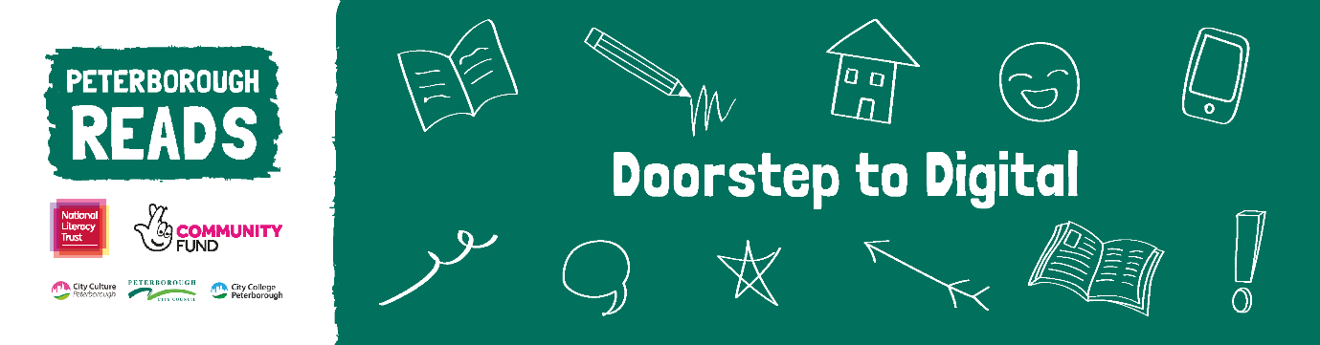
D2D Script
Hello everybody!
My name is Emma Morton and I am the Coordinator for Doorstep to Digital- Peterborough Reads.
If you’re watching this, it hopefully means you’ve received our book pack through one of our community friends or school.
We hope families fall in love with reading and we will show you different ways you can support your child’s reading from home using a digital platform.
We really hope you have found the book pack and resources useful.
If you haven’t done already, please use the QR code in your pack, when you register you’ll be entered into our prize draw to WIN one of eight £25 vouchers! If you win, you can tell us if you’d like an Amazon or supermarket voucher!
After we hear from you, we will send you a really short survey to find out how you’d like me to keep in touch with you. I’ll then send you info and ideas on how to use the packs at home to help support your child’s reading.
There will be lots of ways to get involved going forward! For example, you could join our WhatsApp group where we’ll chat and share ideas on how to support our children’s reading at home. You can also join us on Zoom get where we’ll invite star guests to chat to us and answer your questions.
Group chats, activities and video sessions will be organised by age group of children, they will be friendly and informal. The first session will take place in Feb. There will be different groups for nursery aged children, primary and secondary. We’ll send you all the details, once you have registered.
I love sharing books and there’s always something new to learn and different types of books to engage with. There’s no one size fits all and no reading material is wrong. We’ll share lots of ideas to help get your children reading over the next few months.
If you have any questions do get in touch – just click on the link below to send me an email or text using the number in the welcome letter – you can also request to be signed up for the sessions if you haven’t already registered.
It’s great that you are here and I’m looking forward to seeing you again over the next few months. In the meantime, enjoy your books and keep reading.

