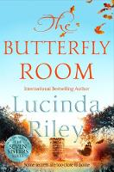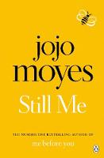

## Still Me

**Author:** Jojo Moyes

**Publisher:** Penguin

**Genre:** Romance

*Also available as an ebook and audiobook*

## The Butterfly Room

**Author:** Lucinda Riley

**Publisher:** Pan Macmillan

**Genre:** Romance

*Also available as an ebook and audiobook*

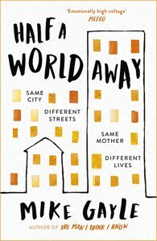

## This is Going to Hurt: Secret Diaries of a Junior Doctor

**Author:** Adam Kay

**Publisher:**  Picador

**Genre:** Non-fiction

*Also available as an ebook and audiobook*

## Half a World Away

**Author:** Mike Gayle

**Publisher:** Hodder & Stoughton

**Genre:** Thriller

*Also available as an ebook and audiobook*

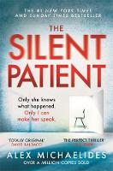

## The Silent Patient

**Author:** Alex Michaelides

**Publisher:** Orion

**Genre:** Thriller

*Also available as an ebook and audiobook*

## Big Little Lies

**Author:** Liane Moriarty

**Publisher:** Penguin

**Genre:** Thriller

*Also available as an ebook and audiobook*

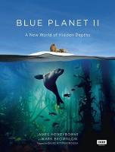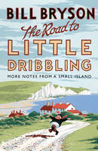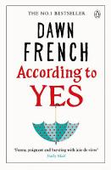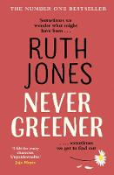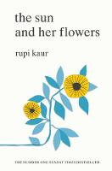

## The Road to Little Dribbling

**Author:** Bill Bryson

**Publisher:** Black Swan

**Genre:** Humour

*Also available as an ebook and audiobook*

## Blue Planet II

**Author:** James Honeyborne, Mark Brownlow

**Publisher:** BBC Books

**Genre:** Non-fiction

*Also available as an ebook*

## The President is Missing

**Authors:** Bill Clinton, James Patterson

**Publisher:** Arrow

**Genre:** Political thriller

*Also available as an ebook and audiobook*

## The Sun and Her Flowers

**Author:** Rupi Kaur

**Publisher:** Simon & Schuster

**Genre:** Poetry

*Also available as an ebook*

## Never Greener

**Author:** Ruth Jones

**Publisher:** Black Swan

**Genre:** Romance

*Also available as an ebook and audiobook*

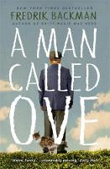

## I Am Malala

**Authors:** Malala Yousafzai, Christina Lamb

**Publisher:** Weidenfeld & Nicolson

**Genre:** Biography

*Also available as an ebook and audiobook*

## A Man Called Ove

**Author:** Fredrik Backman

**Publisher:** Sceptre

**Genre:** Humour, feel good

*Also available as an ebook and audiobook*

## According to Yes

**Author:** Dawn French

**Publisher:** Penguin

**Genre:** Humour

*Also available as an ebook and audiobook*