Safety Awareness & Poetry Resource

With Alison Cope and Kurly McGeachie

Quick Introduction
This safety awareness poetry resource features two leading consultants in anti-youth violence and creative writing. Their short videos are useful guides for keeping safe and support the writing tasks that follow. Watching their short videos is advised.

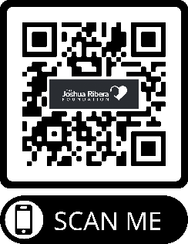
Alison Cope is an anti-youth violence campaigner who has spoken to hundreds of thousands of young people, helping them understand the importance of making positive choices.
Watch Alison’s short video about keeping safe by clicking on the link or scanning here:
https://youtu.be/GR2M5Y2cz6g
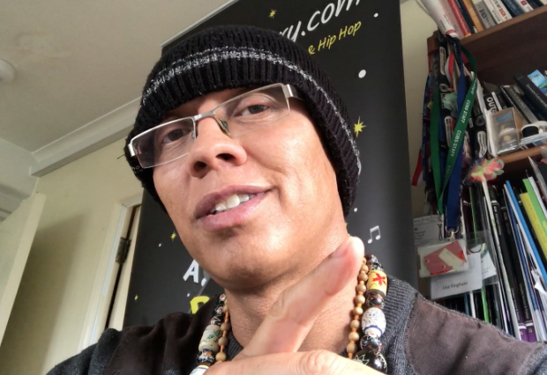
Kurly McGeachie is a poet and workshop facilitator and works with schools throughout the UK to help build literacy confidence. Kurly will help you through the poetry/rapping tasks in this resource.
Click on the link or scan here to watch Kurly’s video: https://youtu.be/dGLgXj3v4CQ

Angry Words! How do you feel?
When we’re calm we can make better choices. Sometimes we can feel a bit heated, annoyed and angry. Expressing how we feel can help us feel calmer. Here is a temperature scale of emotions, useful words to use to help us out during these moments.

I am feeling…
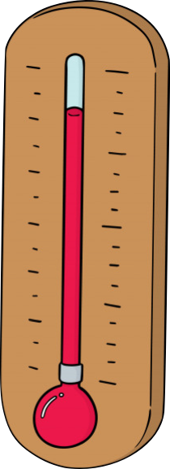
10. Rage, explosive

9. Ballistic, kicking off

8. Livid, seething, hateful

7. Furious, fuming, very angry, vexed

6. Angry

5. Mad

4. Heated, distressed, hurt

3. Upset, sad, let down, peeved

2. Worried, nervous, misunderstood

1. Concerned, annoyed, irritated

0 Relaxed, fine, nice, calm, normal

-1 Cool, chilled

Emotions Poem!
Some people say that I’m strong willed
They think I’m cool because I’m so chilled
Being rude is something to avoid
Show respect or I might get annoyed
Her hair looks ‘sick’ which means ‘really good’
But I was worried of being misunderstood
I ran for the ball and fell in the dirt
When my mates laughed I felt kind of hurt
When my bedroom is in a mess
I can’t find my phone and feel distress
Being cruel to animals is really sad
It upsets me and makes me feel mad
Our planet’s pollution is at a bad stage
It makes my blood boil into a rage!
Sharing feelings helps to build trust
What do our feelings say about us?

Quick questions for you…

What causes you to feel anger?……………………………………………………………………………………..

What makes you feel annoyed?…………………………………………………………………………………….

How do you chill out and relax?......………………………………………………………………………………

Create a positive acrostic poem!

Complete an acrostic poem with the following guide. Each line starts with a word beginning with the letters below. For example, Choose love, Healthy hobbies, Open mind, I enjoy sports, Creativity is fun, Each of us is special.

C…………….…

H…………….…

O………….……

I…………..……

C……………….

E……………….

Another example:

Calmly,

Helping,

Others,

Increase,

Confidence

Everyday!

Now try writing a SAFETY acrostic poem…

S…………….…

A…………….…

F…………….…

E…………….…

T……………….

Y……………….

How about a POSITIVE acrostic poem?

P…………….…

O………………

S………….……

I…………..……

T……………….

I…………………

V….……..…….

E……………….

A short rhyming poem about keeping safe

Me and my friends were chatting by text
One said something that made me feel vexed
I said how I felt and had my say
That’s when the anger faded away

Instead of being mad I used my voice
That was a really positive choice
I didn’t want to fight or get in trouble
The pain for loved ones might be double

I spoke with an adult, calm and nice
They gave me lots of good advice
Respect is there for me and you
Keeping safe is what we do

Lets try writing a rhyming poem using some of the words and ideas on the next page…

Rhyming Rap/Poem - Prep! Mind map of ideas/words & rhyming words

Below are some ideas and rhyming words to do with safety and positive choices. 1st task is to see if you can add a few more ideas and rhyming words below!
x
Police/peace
arrest/success mistake/break
time/crime handcuff/tough prevent/intent bars/stars cell/well tag/bag fine/line judge/budge sad/had harm/calm
stress/mess record/afford
worry/hurry
heart/apart station/situation
say/away
Safety and
Positive Choices
Choice/voice
resilient/brilliant test/best education/motivation decide/provide succeed/need walk/talk
believe/achieve dream/team
inspire/desire idea/clear
role/self control positive/live
trust/must attitude/gratitude
rage/stage nervous/worthless/purpose
family/happily
love/above together/clever argue/do
care/aware respect/protect
mom/from dad/lad online/mine
secure/pure apart/heart away/stay Advice/nice bond/fond
friend/lend
concerned/learned

Rhyme Ladder Example
A rhyme ladder helps us structure our rhyming poem.
Two words that rhyme is called a ‘rhyming couplet’.
Rhyming couplets go in the rhyme boxes here

Can you complete the sentences for the rhyme ladder above? The first two lines are already done. Aim for at least 5 words in each sentence.
away
calm
voice
me
day
choice
agree
harm
We can all make a positive
Instead of fighting use your

Your ‘Safety Awareness’ rhyming poem
Pick pairs of rhyming words/rhyming couplets that you like (use the ‘Safety and Positive Choices Mind Map’ to help). Write your couplets in the rhyme boxes below. Once done write the best sentences you can! Use describing words to help create some great poetry!

Copy your poem down here!

Don’t forget to write your name below it, to show that it is your poem.

This poem was written by…………………………………………………………………………

Bonus task:

To make your poem stand out can you: Perform it aloud? Add beatboxing/actions? Audio record it? Draw pictures/posters? Make a video?

