All the empty spaces, by poet Laila Sumpton
We are living through strange and sometimes scary times- so let’s capture what it’s like through poetry. You’ll learn about two poem forms- the kenning and cinquain, plus write your own poem imagining what is happening in all the empty spaces…

Activity 1: Lockdown kennings
A kenning is a two word poetry phrase which can be a stand alone line, here is the formula:
Noun + verb + er
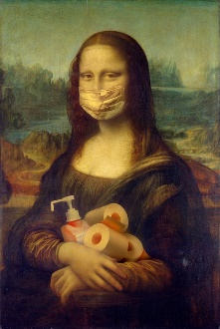
- Make four columns like below.
- Fill in column one and four first: things you need and things you do in lockdown.
- Match the things you need in column 1 with a verb ending in ‘er.’
- Match the things you do in column 4 with nouns.
- Fill out at least 5 rows of your own words.

Noun: things you need in lockdown | Verb + er | Noun: | Verb + er: things we do
Pasta | hoarder | ????? | eater
Netflix | absorber | Dream | scroller
Phone | ?????? + er | Friend | avoider

- Pick the best ones and arrange your kenning poem like this, aim to have your best 10 -12 kennings spread over 5-6 lines.
In lockdown I’m a-
pasta hoarder, dream scroller,
Netflix absorber, friend avoider.

Extra challenge: the lockdown cinquain!
- What are some of the rules and behaviour of the lockdown? Write down the first 4 that come to mind.
- Write about these using the cinquain poetry form- which is great for condensing an idea and trying to make it really vivid. So what is a cinquain??
Tips:
- Syllable: the number of beats each word has, or how many times your chin moves when you say it!
- Find a dramatic to way to end your cinquain with just two syllables.
- Think about what words you end each line with- the eye always lingers longer on the last word.

A five (2)
line poem which (4)
grows by two syllables (6)
at a time: two, four, six, eight, then (8)
just two. (2)

The rule: maintaining 2 metres distance from other people when outside your home.

The cinquain:
Always (2)
stand two metres (4)
away from all humans (6)
(unless you are hibernating (8)
with them). (2).

Activity 2: Watch and read ‘all the empty spaces’
Watch my poetry performance film ‘all the empty spaces’ which imagines what is happening in spaces and places that are now empty.
Some questions whilst you watch and read
- What are the four places described?
- What is the mood in these places?
- Underline the items/creatures have been given human personalities.
- Underline the verbs used to show what these things are doing/feeling.

All the empty places
By Laila Sumpton

fresh trainers doze
in cardboard cages
longing to scuff
any kerb, pitch or dance floor
stilettos teeter
the edge of a twirl
their diamante dusting
day by day

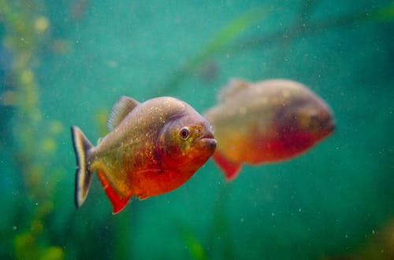
bored piranhas gape
hungry for the staring shoals
that fed this deep sea theatre
a seahorse gets bold
yellow fins flicking fast
no longer hidden in rippling kelp
his belly full and squirming

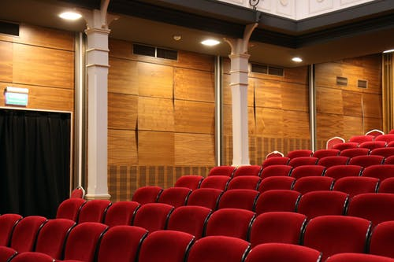
red velvet muffles prop chat
whilst set pulleys slacken
remembering how they lifted Wendy
when she flew after Peter
seats slump as the interval stretches
longer than any they’ve known

markers dry by fading algebra
kings and queens slant and curl
kitchens sigh a hungered electric hum
they left the fridges on
they thought it wouldn’t last long
but empty plates digest the days
wanting to gnaw the crumbs
that are gossiping in the corner

Activity 3: write your own ‘all the empty spaces’
Use this table to build up the content for your own poem about ‘all the empty spaces.’

Pick three places that are now empty due to the lockdown- local shops, places you liked going to near you or in the centre of town.
- What are the things/nouns in theses spaces that stand out to you?
- Personify these nouns! What are they doing/feeling/thinking about whilst the spaces are empty? Feel free to make this as strange as you like- are the wedding dresses waltzing with each other? Are exercise bikes in the gym racing each other?

Place | Nouns/things in that place | Verbs- what are they doing? | How are they feeling?

1

2

3
Tips:
- Your poem does not have to rhyme! Do use rhyme if you happen to find something that works well, but don’t choose rhyme at the expense of what you are trying to say.
- My poem has no grammar, just line breaks- feel free to do the same or to punctuate as you would in prose.
Use the information in this table to write three vivid stanzas about the three places you have chosen- each one up to eight lines long.

Extension: pick an unknown place
Add a fourth stanza to your poem about a place you have never been to but would like to. It could be a shop, a historic building, a zoo, a stadium?
Go to their website for research and use the same table as above to plan your fourth stanza. Where will you travel to? What will be happening there??

