Is your social media profile employment ready?
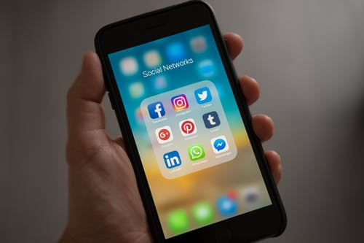
Most of us have heard at least one story of someone losing their dream job after sharing something inappropriate on social media. Here are some simple steps to make sure you are showing your best self online.

Make it private. Social media is your private life. So keep it that way. Your friends may find a post funny but a potential employer may not see the funny side. If you are not sure whether a post is appropriate, it is always best to hold back.

Show your best self. Filter yourself. Even if your profile has all the privacy settings turned on, that doesn’t mean that your pictures and posts are completely untraceable. It’s a good idea to double-check all the photos you post or that others may post of you.

Celebrate your achievements. Posting about your passions, projects and achievements will show potential employers that you are ambitious, productive and talented outside of the workplace.

- Always keep it professional. Think before you post. We all need to vent sometimes but putting your problems or arguments down in writing for everyone to see is not always the best way to do it. You never know who might be reading your posts.

- But try not to be too professional. Holiday posts and snaps about your favourite hobbies show a healthy work-life balance. As a rule, if you would be happy to share an image with your grandma or teacher then it’s probably safe to put it online.

Activity: Digital audit
As embarrassing as it sounds, it is a good idea to occasionally Google yourself.
Enter your full name into Google and check what comes up under the image, news and landing pages. If anything appears that makes you feel embarrassed or that you wouldn’t be comfortable showing your teacher, gran or potential employer, then delete it.

