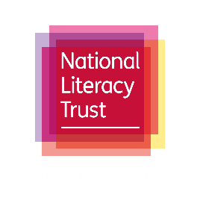

Swindon Literacy Campaign
Schools pledge 2019-20

All schools in Swindon are invited to sign the Swindon Reading Pledge and undertake these ten actions to put reading at the heart of school strategy, community engagement and the classroom.

Strategic
- Review your setting’s oracy provision and its impact on reading and writing, using the relevant sections of the National Literacy Trust’s Annual Literacy Review
- Complete the National Literacy Trust’s annual Children and Young People Reading Attitudes Survey
- Use National Literacy Trust membership resources to inform school strategy and practice

Community
- Once per term send information to all parents asking them to read to and alongside their children
- Send information to parents on library membership and liaise with your local library on school-led engagement sessions
- Engage with a literacy-based activity provided by a community organisation

In-school
- Promote the Summer Reading Challenge and library membership to all eligible pupils
- Organise activities in school such as teacher assemblies and book groups to encourage book talk
- Make and maintain links with your feeder primary schools/local secondary school (depending on your phase) to support pupil transition
- Identify a school governor to have special responsibility for literacy

Signed:

(SCHOOL NAME)

(HEAD TEACHER)

