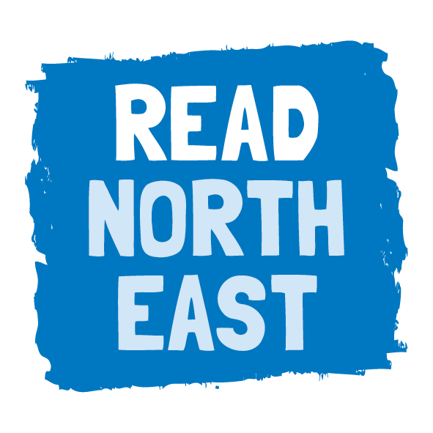

Using the Read North East logo
We encourage partners to use the Read North East logo across their own materials and channels to help us to raise awareness of the campaign and show their support.

Where to use the logo
You could consider using the Read North East logo on:
- Your website
- Your email signature
- Promotional materials with a reading or literacy focus, e.g. posters and flyers
Process for using the logo
- Email Laura Flinn (laura.flinn@literacytrust.org.uk) with details of where you would like to include the Read North East logo
- Laura will send you the logo in the relevant format
- Email Laura the document / a link to the website with the logo so we can keep track of where it is being used
- If your document is for an upcoming event / initiative, you may also want to share it with the North East Literacy forum and highlight how they could help you to promote it on social media
Dos and don’ts
- Where possible, try to include the Read North east web address (readnortheast.org.uk) and hash tag #ReadNorthEast alongside the logo
- Please do not alter or edit the logo in any way
- When your document has a coloured background, please ensure you use the transparent version of the logo

