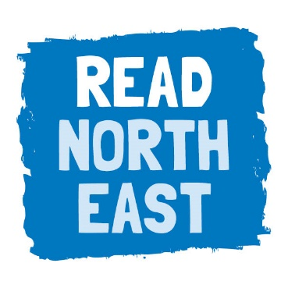

Read North East – suggested web copy for partners

[NAME OF PARTNER] is part of the Read North East campaign, which was launched in March 2017 to raise children’s literacy levels in the North East.

Research shows that 17% of the adult population in the region have literacy skills at or below those expected of a 9 to 11-year-old. Data analysis by the National Literacy Trust and Experian also shows that 60% of the wards in the North East are at risk of low literacy, making it the second most vulnerable region to literacy issues in the country.

Working with partners including the National Literacy Trust, Read North East focuses on early years literacy, encouraging parents to read with their children from birth to give them the best start in life. A series of events and activities are taking place to raise awareness of the importance of literacy skills and inspire local children and families to pick up a book.

Local businesses will also have an important role to play in addressing the region’s literacy challenge.

To find out more and see upcoming events, visit readnortheast.org.uk.

